# Business Overview

Bottled water is one commodity that is consumed in all parts of the world and of course those that are in the business of producing bottled water are known to generate sales year in year out if the business is well – managed. As a matter of fact, economic downturn hardly affects the consumption of bottled water simply because it is a commodity that is as important as the air we breathe in.

Likewise, bulk water is a major required essential in supplying clean water to communities which have no access to treated piped water, as well as for companies which require pure water for key industrial processes.

The City Council in Harare, Zimbabwe is still facing undeniable challenges in supplying adequate treated water to residents and companies primarily due to limited resources in setting up and maintaining effective water treatment plants in the City. Therefor because of this gap in clean water supply, Pure Flow Pvt Limited is being established to contribute to provision of clean water to individuals and companies.

# Company Summary

**Pure Flow**, located in Ashdown Park, Harare, is a water bottling business that sells bulk water and bottled water units to end consumers and companies.

The business will be based at Heartfelt International Ministries premises. It is forecasted that we will reach profitability by month 12, and we will earn modest profits by year three.

# Company Ownership

**Pure Flow** is a private company, founded and owned by **Heartfelt International Ministries**.

**Start-up Summary**

Pure Flow's start-up costs include the following items:

* Material to setup a bulk water collection system i.e. 6 x 10000 litre tanks, Water pressure pump (discharge rate: 500litres/minute), Pvc pipes, Flexible, canvas pipe
* Office furniture, including a desk, chair, and filing cabinets
* Computer system
* Stationery
* Brochures
* Legal fees
* Phone line, cell phone
* Generator

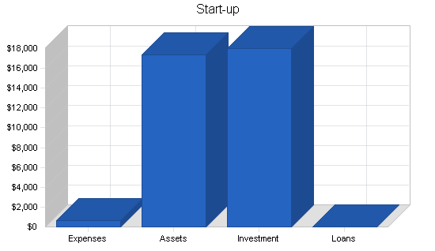

|  |  |
| --- | --- |
| Start-up Requirements | |
| Start-up Expenses |  |
| Legal | $200 |
| Stationery etc. | $200 |
| Brochures | $200 |
| Other | $0 |
| Total Start-up Expenses | $600 |
| Start-up Assets |  |
| Cash Required | $15,100 |
| Other Current Assets | $0 |
| Long-term Assets | $2,300 |
| Total Assets | $17,400 |
| Total Requirements | $18,000 |

|  |  |
| --- | --- |
| Start-up Funding | |
| Start-up Expenses to Fund | $600 |
| Start-up Assets to Fund | $17,400 |
| Total Funding Required | $18,000 |
| Assets |  |
| Non-cash Assets from Start-up | $2,300 |
| Cash Requirements from Start-up | $15,100 |
| Additional Cash Raised | $0 |
| Cash Balance on Starting Date | $15,100 |
| Total Assets | $17,400 |
| Liabilities and Capital |  |
| Liabilities |  |
| Current Borrowing | $0 |
| Long-term Liabilities | $0 |
| Accounts Payable (Outstanding Bills) | $0 |
| Other Current Liabilities (interest-free) | $0 |
| Total Liabilities | $0 |
| Capital |  |
| Planned Investment |  |
| Investor 1 | $18,000 |
| Investor 2 | $0 |
| Other | $0 |
| Additional Investment Requirement | $0 |
| Total Planned Investment | $18,000 |
| Loss at Start-up (Start-up Expenses) | ($600) |
| Total Capital | $17,400 |
| Total Capital and Liabilities | $17,400 |
| Total Funding | $18,000 |

# Products

Pure Flow will take advantage of its easy access to huge supply of clean borehole water to supply the market. Two different products will be sold:

1. **Bulk water**- structures will be made to facilitate selling of bulk water to companies and distributors of clean water.
2. **Bottled Water**- a water testing, purification and packaging system will be installed to package well branded , pure water for public consumption.

# Our Target Market

When it comes to selling bottled water, there is indeed a wide range of available customers. We will engage companies in wholesale distribution and engage the following groups;

* Hotels
* Restaurants and Canteens
* Event Planners, Parties and Corporate Functions
* Corporates
* Government Departments
* Water distribution companies (bulk)
* 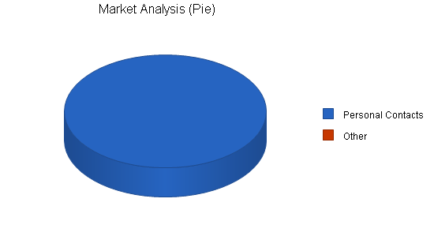

|  |  |  |  |  |  |  |  |
| --- | --- | --- | --- | --- | --- | --- | --- |
| Market Analysis | | | | | | | |
|  |  | Year 1 | Year 2 | Year 3 | Year 4 | Year 5 |  |
| Potential Customers | Growth |  |  |  |  |  | CAGR |
| Personal Contacts | 9% | 560 | 610 | 665 | 725 | 790 | 8.98% |
| Other | 0% | 0 | 0 | 0 | 0 | 0 | 0.00% |
| Total | 8.98% | 560 | 610 | 665 | 725 | 790 | 8.98% |

# Competitor Analysis

# Strategy and Implementation Summary

**Pure Flow** will be aggressively courting personal contacts. Once contacts have been turned into customers, Pure Flow will then attempt to turn them into sales agents for the company. The advantage for them is that they get products at wholesale and receive recurring revenue for sales people they recruit. **Pure Flow** benefits as it gets the recurring revenue for all sales that are made by **Pure Flow**'s customers or the sales agents of its customers. It is a win-win situation and can be easily presented as such.

# Sales and Marketing Strategy

In order to continue to be in business and grow, we will adopt the following sales and marketing approach to sell our products;

* Introduce our bottled water brand by sending introductory letters to residence, bottled water merchants and companies.
* Engage in road shows in targeted communities from time to time to sell our products
* Advertise our products in local newspapers and publications
* Leverage on the internet by developing a vibrant website to promote our bottled water and bulk water brands
* Engage in direct marketing and sales
* Encourage the use of Word of mouth marketing (referrals)

# Sales Strategy

**Pure Flow** sales strategy will be based on leveraging personal contacts. Typically, an informal meeting will be set up with the prospective customer. A brochure will be introduced with product information about our products.

# Sales Forecast

The first month will be spent setting up the office. There will be minimum sales activity.

The second month will be the first month of real sales. During this month the company will have signed people up and revenue will be trickling in. It will not be until month five when revenue begins to get strong. Month six will be the first month when the recurring revenue will come in from Pure Flow's recruited sales people.

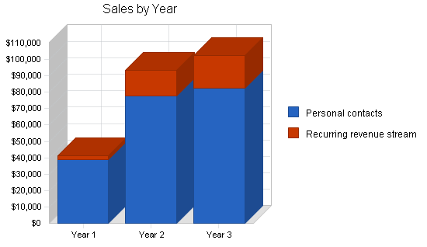

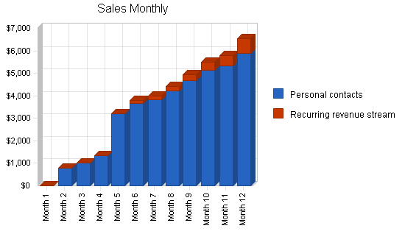

|  |  |  |  |
| --- | --- | --- | --- |
| Sales Forecast | | | |
|  | Year 1 | Year 2 | Year 3 |
| Sales |  |  |  |
| Personal contacts | $39,091 | $77,854 | $82,547 |
| Recurring revenue stream | $2,189 | $15,447 | $19,874 |
| Total Sales | $41,280 | $93,301 | $102,421 |
| Direct Cost of Sales | Year 1 | Year 2 | Year 3 |
| Personal contacts | $19,546 | $38,927 | $41,274 |
| Recurring revenue stream | $0 | $0 | $0 |
| Subtotal Direct Cost of Sales | $19,546 | $38,927 | $41,274 |

# Milestones

**Pure Flow** will have several milestones early on:

1. Business plan completion. This will be done as a road map for the organization. The business plan will be an indispensable tool for the ongoing performance and improvement of the company.
2. Office set up.
3. First recurring revenue to come in.
4. Profitability solely from recurring revenue.

|  |  |  |  |  |  |
| --- | --- | --- | --- | --- | --- |
| Milestones | | | | | |
| Milestone | Start Date | End Date | Budget | Manager | Department |
| Business plan completion | 1/1/2001 | 2/1/2001 | $0 | ABC | Marketing |
| Office and Factory set up | 1/1/2001 | 2/1/2001 | $0 | ABC | Department |
| First recurring revenue to come in. | 1/1/2001 | 5/1/2001 | $0 | ABC | Department |
| Profitability solely from recurring revenue | 1/1/2001 | 9/1/2001 | $0 | ABC | Department |
| Totals |  |  | $0 |  |  |

# Our Pricing Strategy

When it comes to pricing for products such as bottled watered, there are two sides to the coin. We are aware of the pricing trend in the bottled water production industry which is why we have decided to produce various sizes of bottled water.

In view of that, our prices will conform to what is obtainable in the industry but will ensure that within the first 6 to 12 months our products are sold a little bit below the average prices of various bottled water production and bulk water supply brands. We will put in place business strategies that will help us run on low profits for a period of 6 months; to encourage people to buy into our bottled and bulk water brands.

# Payment Options

Our payment policy is will be all inclusive because we are quite aware that different people prefer different payment options as it suits them. Here are the payment options that will be available to facilitate payments;

* Payment by cash
* Payment via Point of Sale (POS) Machine
* Payment via online bank transfer (online payment portal)
* Payment via Mobile money

In view of the above, we will choose a bank that will help us achieve our payment plans without any hitches.

# Team